The University Of Azad Jammu and Kashmir,Muzaffarabad



Student Name: Adeela Bashir
Class Rollno: 2024-SE-12
Course Title: Database Systems
Instructor: Engr.Awais Rathore

Department of Software Engineering
Aim of the Lab
The purpose of this lab was to learn the fundamentals of database creation, table design, and inserting records into those tables. These are the initial steps required when setting up any type of database system

Setting Up the Database
I started by creating a database named university_labs using SQL commands in MySQL (XAMPP). This served as the foundation for all the tables that were added later.



Building the Department Table
The first table created was Department. After defining its structure, I inserted sample records into it to represent different departments

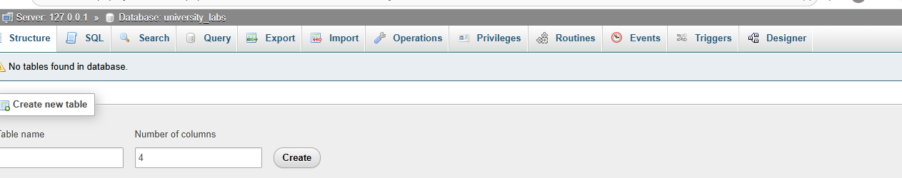

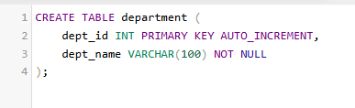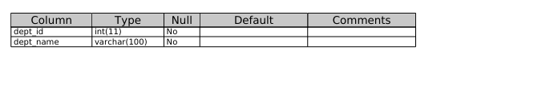
Data:
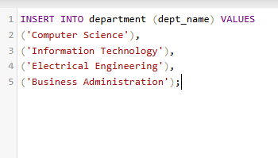
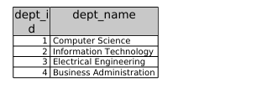
Adding Data for Students
Next, I created the Student table. This table included fields such as id, name, email, and department_id. Once the structure was ready, I inserted data into it to store student details.

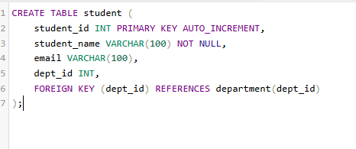
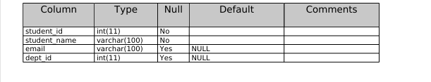

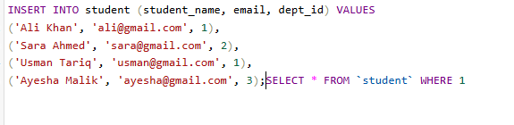
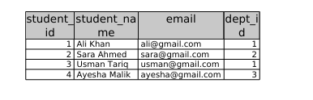
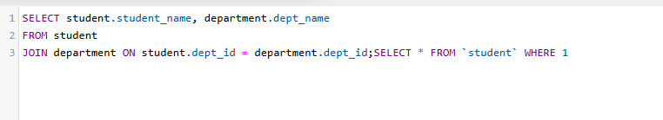

Instructor Table
An Instructor table was also created to manage teacher information. This table helps in linking courses with the respective instructors.

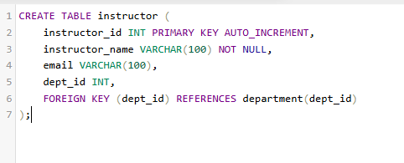
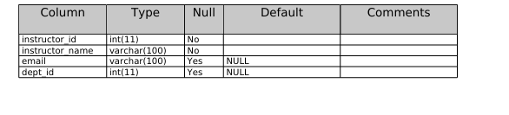
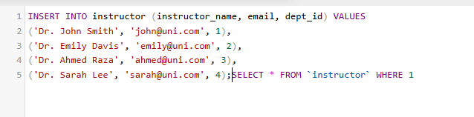
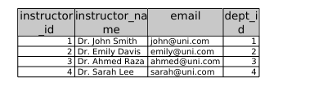

Course Table
The Course table was designed to store course-related information. It works alongside the instructor and student tables to represent the academic structure.

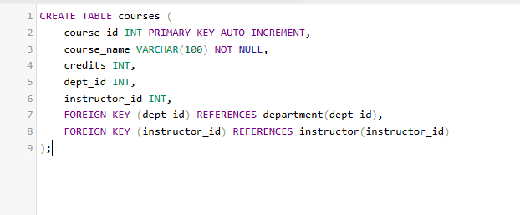

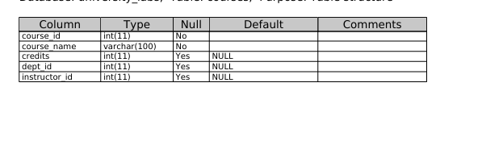

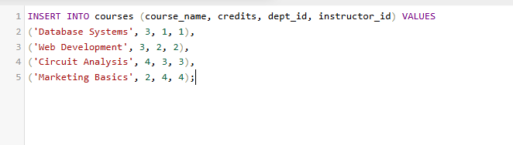
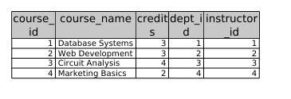
Enrollment Table
Finally, the Enrollment table was added. This table connects students with the courses they register for, making it possible to track which student is enrolled in which course.

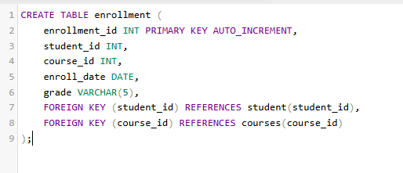
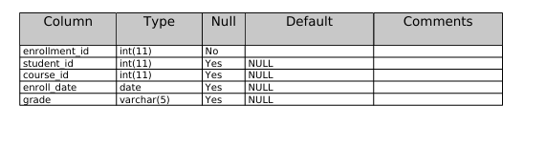
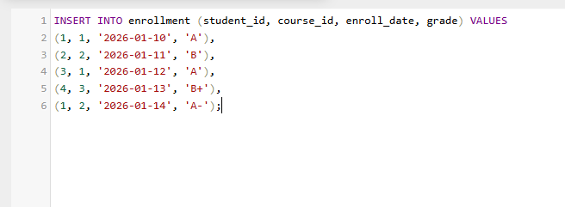

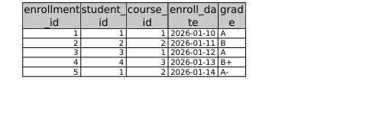

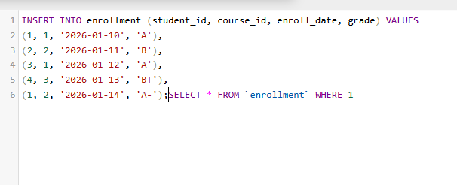

Reflection
Through this lab, I practiced the basic yet essential steps of database development: creating a database, defining tables, and inserting records. This exercise gave me a clear understanding of how different tables interact and how data is organized in a relational database

………………………………………………………………………………

